|  |  |  |  |  |  |
| --- | --- | --- | --- | --- | --- |
| Name | Siddharth Sigtia | | | | |
|  |  | | | | |
| Student Number | 120120770 | | | | |
|  |  | | | | |
| Email address | s.s.sigtia@qmul.ac.uk | | | | |
|  |  | | | | |
| Institute/School | Electronic Engineering and Computer Science | | | | |
|  |  | | | | |
| Primary Supervisor | Simon Dixon | | | | |
|  |  | | | | |
| Initial enrolment date | **24 September 2012** | | | | |
| Year of study (please circle) | **1** | **2** | **3** | **4** | **Writing Up** |
| Final Submission date | **24 September 2016** | | | | |
|  |  | | | | |
| Thesis Title | Improving Music Information Retrieval tasks with Neural Networks | | | | |
|  |  | | | | |
| **Main source of studentship funding (e.g. AHRC, NERC, QMUL, self-funded):** | | | | | |
|  |  | | | | |
|  | Self-funded | | | | |
| **Requested funding breakdown:** |  | | | | |
| *Cost category* | *Total amount* | *Amount requested from PGRF* | *Amount sought from other funders* | | |
| Accommodation | 250 | 250 | 0 | | |
| Conference registration | 300 | 300 (if not awarded by ISMIR) | 300 to be requested from ISMIR student travel fund; applications open next month | | |
| Subsistence | 150 | 150 | 0 | | |
| Travel | 760  flight(750);  Airport Shuttle Service(10) | 760 | 0 | | |
| Other research expenses (please specify) | 0 | 0 | 0 | | |
|  |  |  |  | | |
| Other expenses (please specify) | 96 (visa) | 96 (visa) | 0 | | |
|  |  |  |  | | |
| *Total* | 1546 | 1546 | 0 | | |
|  | | | | | |
| Have you previously applied to the fund? | Yes |  | No | **No** | |
| **If ‘Yes’, please state when and amount awarded** *(if any)* | **Date** |  | **Amount** |  | |

**Brief description of the purpose and significance of these expenses in relation to your research.** If you are applying to support a presentation at a conference please provide the title of your paper or poster, date, location and title of conference and the reasons it is important to present at this particular conference. Do NOT include a detailed description of your thesis, or the presentation's abstract. Include the location and dates of the event.

If you are applying to visit an overseas research institution please describe exactly why the visit is important for your research and the lasting impact, on future collaborations for example.(*Max 500 words)*

This application is to request funds in order to attend **The 15th International Society for Music Information Retrieval (ISMIR)**conference. The conference takes place between **27th-31st of October**in **Taipei, Taiwan**.

I have submitted a paper titled ‘**RNN-based Music Language Models for Improving Music Transcription’**. This is my first attempt at applying neural networks to a practical, large-scale problem in Music Information Retrieval. Learning statistical models that capture the temporal structure of symbolic music has always been an open problem in Music Information Retrieval (MIR). In this paper we demonstrate the effectiveness of neural network based models for learning temporal structure and also present a way of incorporating this information in a music transcription system. Our results are very encouraging and show an overall improvement over existing methods over several tasks.   
  
ISMIR is the most relevant community to present my work to. It is a highly selective and specialised conference with MIR as its main focus. Automatic music transcription is one of the fundamental problems in MIR and therefore ISMIR would be the ideal place to present this work. Attending the conference will give me the opportunity to share my ideas and results with other people who are experts in the field and also obtain ideas for pursuing this thread of research in the future.

This publication (if accepted) will be my second publication in my PhD research which explores the application and extension of neural networks for solving problems in Music Information Retrieval. ISMIR and related signal processing communities have started experimenting with neural networks and evaluating their use for solving various problems. Last year there was a tutorial on the application of neural networks to MIR at ISMIR which shows that there has been a lot of interest generated on this particular subject. Therefore apart from sharing my ideas with the wider ISMIR community, there is also a subset of people who are very interested in the specific methods that I apply in my own PhD research. It would be a great opportunity to meet them and exchange ideas and results.

Please provide **brief** **details of any conferences you have previously attended or presented at**:

I presented my paper '**Improved Music Feature Learning with Deep Neural Networks**' at ICASSP 2014 in Florence. The paper explored the methodology for work that I have submitted to ISMIR.

Please provide details of any **external funding** for which you have applied in relation to these expenses

I will be applying to the travel fund provided by ISMIR. I am waiting for the application dates to be announced (expected in June) so that I can submit my application. In previous years, the ISMIR student travel fund has provided support for registration only; we expect this to be the case again this year.

**Signature** (type name if submitting electronically) Siddharth Sigtia

**Date 14 May 2014**

**Supporting statement from supervisor**. This statement should include confirmation of the ways in which the intended activity will contribute to the doctoral research and/or knowledge transfer and if external funding has not been secured, why this has not been possible (*Max 500 words*).

I would like to express my strongest support for this application. The ISMIR conference is the top international conference in Music Informatics, and thus the most important conference for myself and most of my students. In terms of citations, it is ranked in the top 5% of Computer Science conferences (http://academic.research.microsoft.com/). Because of its strong specialisation, most world-leading researchers in the area make the effort to attend. Therefore, it will be of great benefit for Mr Sigtia to present his work to that community, both for the feedback which he will receive and for the dissemination of our research to enhance the international profile of QMUL. It is also an excellent opportunity for him to learn about the latest advances in the field. Like many computer science conferences, full papers are submitted for review (in this case 3 reviewers) and the majority of submissions are not accepted for the conference. Thus it is an achievement for a student to have a paper accepted at the conference.

Mr Sigtia is an outstanding student and he is making excellent progress, this being his second paper at leading international conferences (ICASSP and ISMIR). Being in the 2nd year of his PhD, this is the ideal time for him to expose his initial work to public scrutiny and receive feedback which will help to shape the direction of the rest of his PhD.

Mr Sigtia is an unfunded PhD student, who is working part time to support his studies, thus he has no travel funding of his own. The society running the conference (ISMIR) will offer student travel grants (to be announced in June), and Mr Sigtia will apply for this. Based on previous years, we assume that this will cover registration only, which allow us to reduce the sum claimed from the PGRF. As far as I am aware, this is the only source of external funding to which he is eligible to apply.

From the point of view of the Centre for Digital Music, it is important for us to have a strong presence at ISMIR, in order to maintain our reputation as one of the world's top research groups in the area of Music Informatics. I give my strongest support to this application.

**Supervisor's signature** (type name if submitting electronically) Simon Dixon

**Date 16/5/14**

**Please return this completed form to:**

Your School/Institute administrator, at the deadline set by them (which will be at least a week before the dates given below) who will then collate and forward on to [qmpgrf@qmul.ac.uk](mailto:qmpgrf@qmul.ac.uk) all the applications from your School/Institute.

**Sign off from Director of Graduate Studies/Research**

**Signature:**

**Date /5/14**

SCHOOL ADMINISTRATORS ARE REQUESTED TO ENSURE THEY HAVE OBTAINED SIGN-OFF BEFORE SUBMITTING ALL APPLICATIONS FROM YOUR SCHOOL TO [qmpgrf@qmul.ac.uk](mailto:qmpgrf@qmul.ac.uk)

**There are three annual deadlines, with the Panel convening to consider applications each term. The final deadlines for the submission of applications from Schools/Institutes are:**

**1 October**

**1 February**

**1 June**

**Snapshot for Flight Tickets**

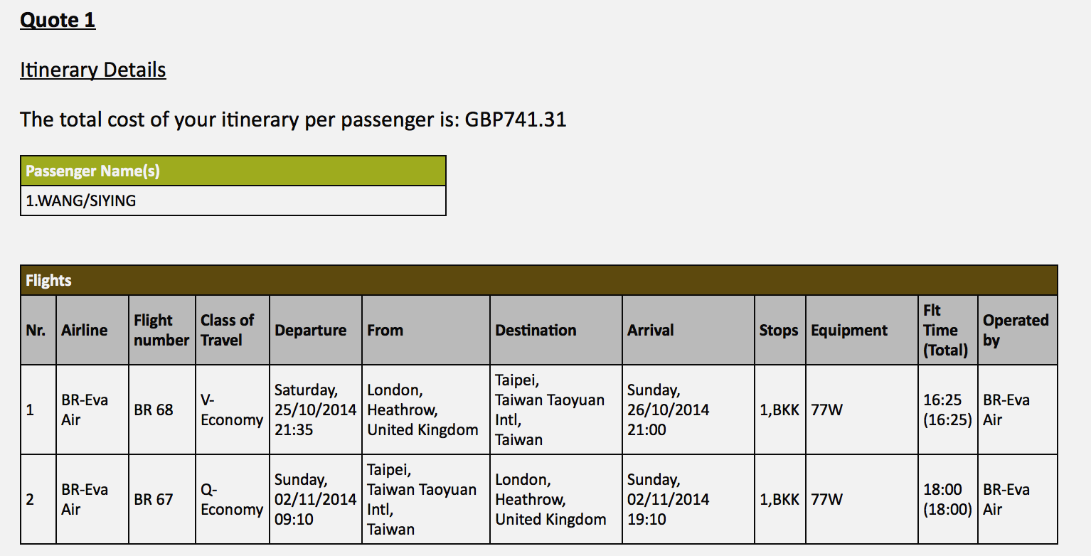

**Snapshot for Accommodation**